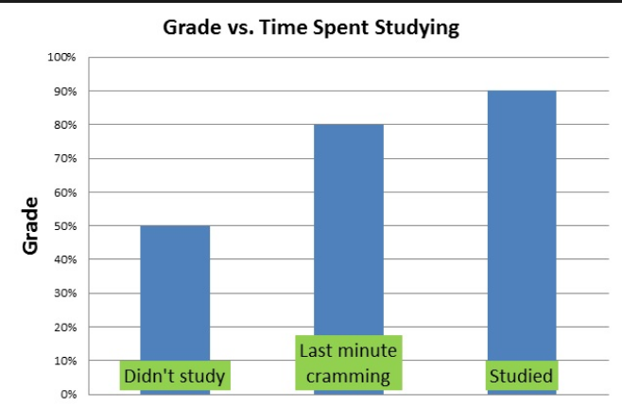**Description of a Graph**

**ESL 389T**

**Goal:** Give a comprehensible **3-minute** presentation of a visual to the whole class.

**Purpose:** Practice using the format to describe a visual. Choose appropriate expressions. Focus on correct primary stress in thought groups and eye contact.

**Preparation:**

**Part 1: Choose a Visual**

* Choose a REAL visual on a general topic, e.g., technology, education, history, world population. Feel free to choose an infographic from Statista (that’s where we pull graphs from for the ITA assessment).
* In your introduction, tell us **why you chose this visual** and what its importance is.

**Part 2: Consider your Audience**

1. What **background information** do they need to understand your visual?
2. What **symbols or terms** do you need to explain or clarify for your audience?
3. What **specific examples** can you include to show how to interpret the visual?

**Part 3: Prepare your Presentation**

1. **Use the Structured Method for Explaining a Visual**
2. **Review the Language for Describing Graphs**
3. **Discourse Markers:** Consult the Discourse Marker handout for other functional phrases and connectors.
4. **Define any terms that your audience may be unfamiliar with:** Choose a strategy for your brief explanation (practical example, personal example, analogy, comparison/contrast, word origin, visual means) and write the explanation in your own words that will clearly express the meaning of the term.
5. **Closing:** See Presentation Language handout for more ideas.
6. **Invitation for Questions:** See Presentation Language handout for more ideas.

**Structured Method for Explaining a Visual:**

**1.** **Introduce the visual by give its title, name, or purpose:**

1. The (title) of this graph is
2. This (model) is called a
3. This (chart) shows the relationship between . . .
4. I think this (diagram) will help you understand . . .

**2. Discuss the overall organization, layout, or structure of the visual:**

1. In this (graph), the (x-axis) represents . . . and the (y-axis) represents . . .
2. This (mechanism) has (four) main parts: . . .

**3.** **Explain any symbols, terms, or other information that may be new for your audience:**

1. Let’s look at the (key). As you can see, . . .
2. Notice that (A) denotes . . . and (B) denotes . . .

**4. Give at least one specific example that demonstrates the type of information the visual contains:**

1. Let’s look at one point on the (graph) . . .
2. If you look at the (first) item in the (left) column . . .

**5. Discuss overall trends or patterns or make predictions based on the information conveyed by the visual:**

1. Note the (peaks) at . . .
2. In general, you can see that . . .
3. If this trend continues, we will find that . . .
4. This information suggests that . . .

**6. Close by summarizing the points you wish to emphasize regarding the visual:**

1. In summary,
2. To conclude,

① Title, purpose

② Axes, parts

③ Symbols, terms

④ Specific characteristic

⑤ Patterns, predictions

⑥ Summary

**Language for Describing Graphs**

**Increase**

go up (verb)

upward (adj)

rise (verb/noun)

increase (verb/noun)

grow (verb)

growth (noun)

climb (verb/noun)

**Big Increase**

rocket (verb)

surge (verb/noun)

**Decrease**

downward (adj)

fall (verb/noun)

go down (verb)

decline (verb/noun)

drop (verb/noun)

decrease (verb/noun)

dip (verb/noun)

**Big Decrease**

plunge (verb)

collapse (verb/noun)

nosedive (verb/noun)

plummet (verb)

**Change**

fluctuate (verb)

fluctuation (noun)

undulate (verb)

undulation (noun)

**Small Change**

gradual (adj)

gradually (adv)

slight (adj)

slightly (adv)

**Big Change**

considerable (adj)

considerably (adv)

dramatic (adj)

dramatically (adv)

steep (adj)

sharp (adj)

sharply (adv)

significant (adj)

significantly (adv)

**Lots of Changes in Many Directions**

wild (adj)

wildly (adv)

erratic (adj)

erratically (adv)

**At the Same Rate**

steady (adj)

steadily (adv)

**No Change**

stable (adj)

remain (verb)

plateau (verb/noun)

level off (verb)

maintain (verb)

stay (verb)

**Prepositions**

*Between* 1995 *and* 2000

*From* 1995 *to* 2000

*In* (month)

*In* (year)

The population fell *by* 50%

**No Movement:**

remained steady

were unchanged

did not change

remained constant

remained stable

**Tops and Bottoms:**

reached a peak

peaked

reached their highest level

fell to a low

sank to a trough

bottomed out



**Great Graph Phrases**

Directions: Practice the phrases below. You can practice with the audio recording in Canvas. Pay attention to the stress intonation, rhythm, and linking.

|  |  |
| --- | --- |
| **#** | **Phrase** |
| 1 | The title of this graph is… |
| 2 | This chart shows the relationship between …. and …. |
| 3 | This diagram represents….and depicts……. |
| 4 | In this graph, the y-axis shows… |
| 5 | In this graph, the x-axis represents… |
| 6 | Let’s look at the key…as you can see the …. |
| 7 | In general, you can see that… |
| 8 | This information suggests… |
| 9 | If this trend continues…. |
| 10 | In summary, what the graph shows is… |

**Sample Graph and Script:**

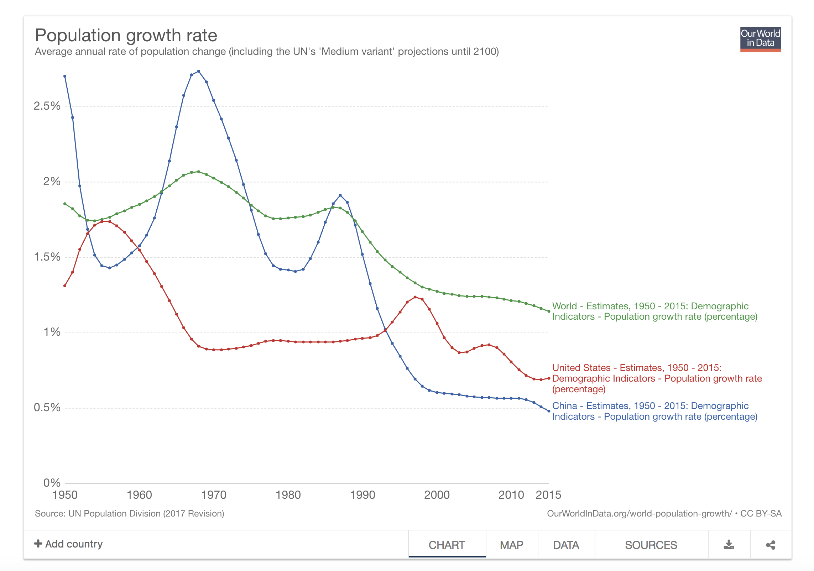

So, the graph that I will introduce is about the population rate. The title of this graph is Population Growth Rate. It’s from a website called Our World in Data.

In this graph, the y-axis represents the population growth rate, and the x-axis represents the year from 1950 to 2015 in increments of 10 years. Three curves are shown in this graph. Specifically, the red curve represents the evolution of the population growth rate for the United States, the blue curve shows the evolution of the population growth rate for China, and the green curve is for the world as a whole.

Let’s look at these three curves one by one. Let’s first have a look at the red curve. As we can see, for the United States, there was an increase from 1950 to 1960, while for the following ten years, the United States’ population growth rate kept decreasing, stabilizing at around 1% by 1970. From 1970 to 1990, the growth rate remained at the same level, followed by an upturn at the end of the 20th century. After entering the 21st century, the growth rate decreased overall with fluctuation.

Second, let’s take a look at the population growth rate of China. It’s interesting to observe that from 1950 to the end of the 20th century, the population growth rate of China almost held opposite trend to that of the United States. It increased sharply in the 1950s and declined sharply in the 60s. The US, on the other hand, experienced a dramatic decrease in the first several years of 1950s and a remarkable increase from the beginning of the 1960s.

Finally, let’s look at the green curve, which represents the average growth rate of the world. We can regard this as an average of the United States, which represents developed countries and China who represents developing countries. Accordingly, we can infer that from 1990, the overall tendency of the population growth rate is decreasing. If this trend continues, we may be worried about the forthcoming aging societies for the entire world.

Overall, this graph shows the fluctuations in the population growth rates for the United States, China, and the world. We can conclude that for the US, the overall change has been much smoother than for China, whose growth rate has fluctuated dramatically over the last 50 years. However, from the beginning of the 21st century, the growth rates have been concurrently decreasing for the US and China, and even for the whole world.

**Expressions for Question-and-Answer Sessions**

**The Audience – Thanking and Asking**

**Thank the Presenter**

* Thank you for your interesting/useful/informative/

fascinating/important presentation/talk.

**Ask for Clarification**

* I didn’t quite understand what you said about . . . .

**Ask for Confirmation**

* Did you say that . . . ?
* If I understood you correctly, you said . . . ?

**Ask for Repetition**

* Could you repeat what you said about . . . ?

**Ask for Further Information**

* Could you tell us more about . . . ?
* I was very interested in what you said about . . . .
* I was wondering . . . .

**The Presenter - Handling Questions**

**Welcome the question**

* Go ahead.
* Shoot.

**Buy Time**

* That’s a good question.
* That’s interesting.

**Repeat the question and/or clarify it**

* Did everyone hear the question?
* The question was . . . .
* If I understood you correctly, you’re saying/asking . . . .
* I’m not sure what you’re getting at.

**Check that the questioner is satisfied**

* Does that answer your question?
* Is that clear?

**You are out of time**

* I’m sorry but our time is up. I’d be happy to talk with you more outside after the session.

**Visual Presentation Evaluation Form (50 points total)**

Speaker:_________________________________

Topic: ___________________________________

The following key will be used to evaluate your presentation:

5 4 3 2 1 0

excellent good! okay weak missing

**Organization and Content:**

_____ Greeted audience and gave clear introduction of topic

_____ Gave overview of visual and its importance

_____ Used discourse markers to move from one point to the next

_____ Gave specific example

_____ Discussed overall trends or patterns and/or made predictions

_____ Summarized points he/she wanted to emphasize

**Visual:**

_____ Clear and understandable (no more details than necessary)

**Communicative Ability:**

_____ Pronunciation (stress on key words, linking)

_____ Spoke fluently (not much hesitation or repetition)

_____ Eye contact (to both sides of room)

Good Points about this Presentation:

Points to Improve: